Recap on the presentation and the main results:

We can see a clear narrative in the main sample results and in each of the sub-samples based on job separation types.

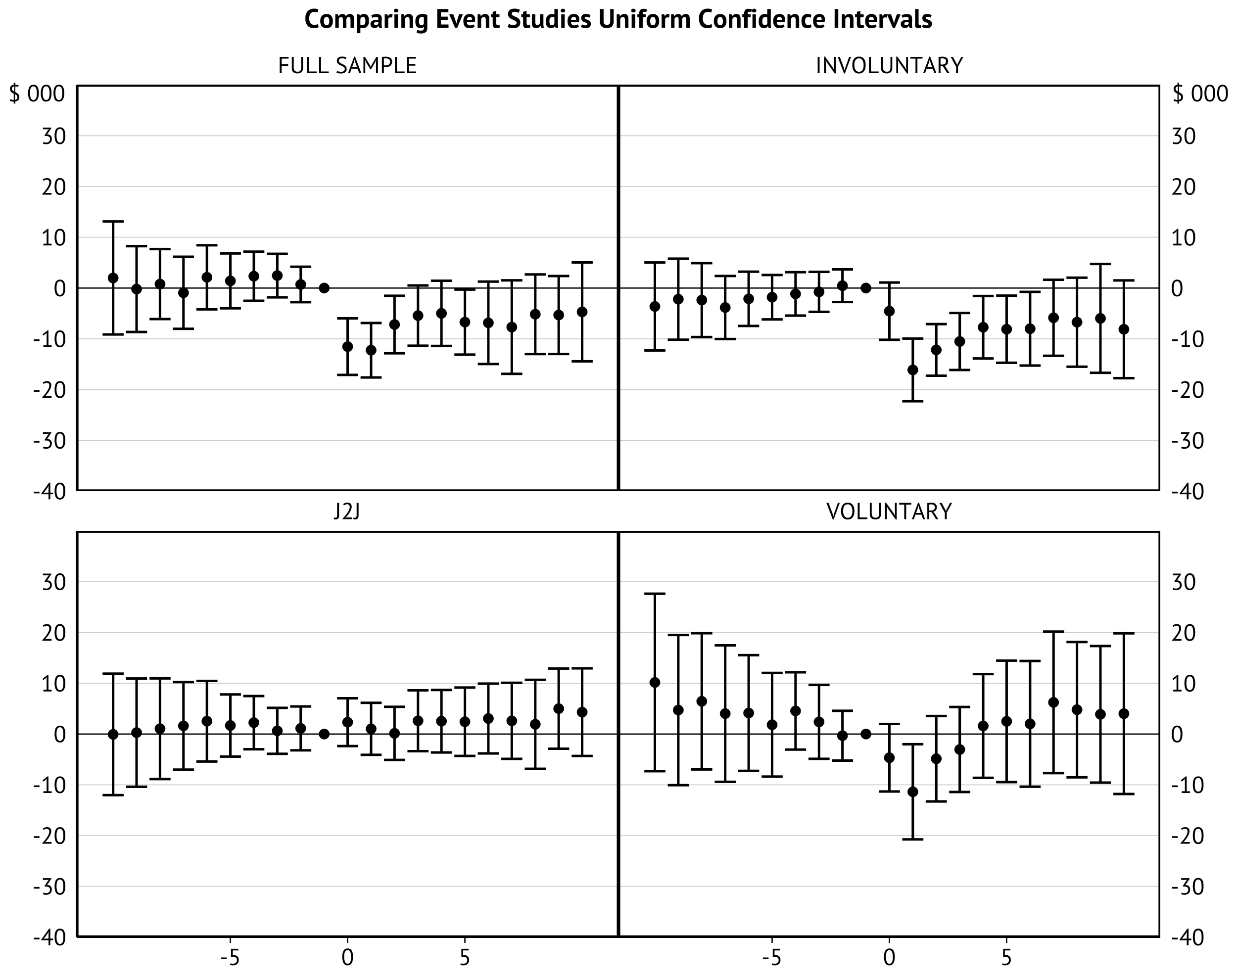

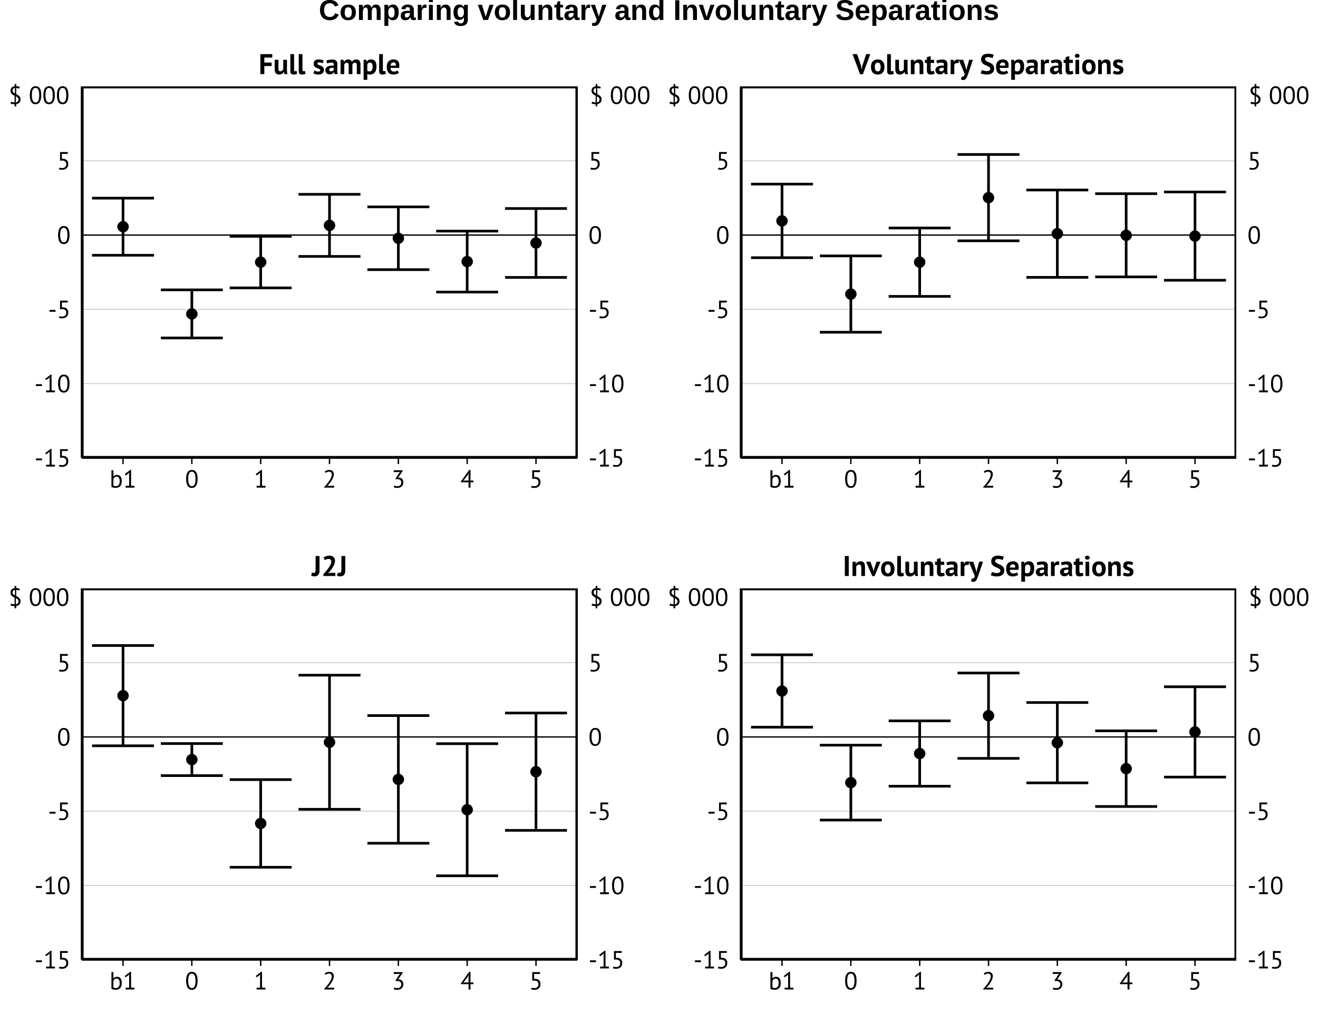

The main results from the presentation indicated that most of the negative effects of

Separation from employment are felt by those who involuntary separate from their job. This puts us at odds with previous findings (Lancaster 2021; Coates and Ballantyne 2022). However, this is likely to the sensitivity of these results to problems related to TWFE estimators in general. i.e there is a clear impact related to forbidden comparisons.

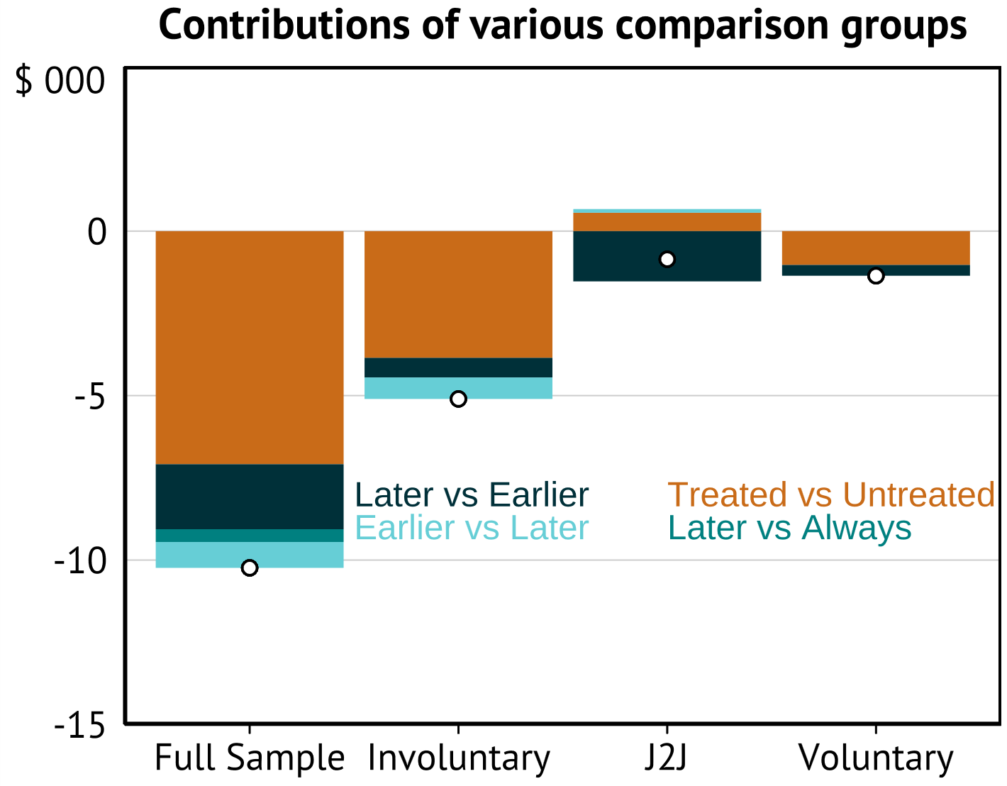

Following on from the presentation we were interested in whether this decline in wage earnings was related to workers being unable to return to their previous intensity of work after the initial separation (i.e hours) or if the apparent penalty was through the hourly wage. We seem to find that at least for the involuntary separators, the penalty is largely a result of a lower wages per hour worked. There is no impact on the J2J or voluntary groups.

There is a third option for what could be generating the initial drop in incomes. The income that we record is also related to the amount of time in the year spent employed. This implies that there could be a drop in earnings overall for the groups without any particular drop in typical weekly hours or earnings per hour worked. That we find no discernible effects on these outcomes for the Voluntary and J2J groups tells us that the earnings penalties for these groups are different in kind to that of the Involuntary leavers.

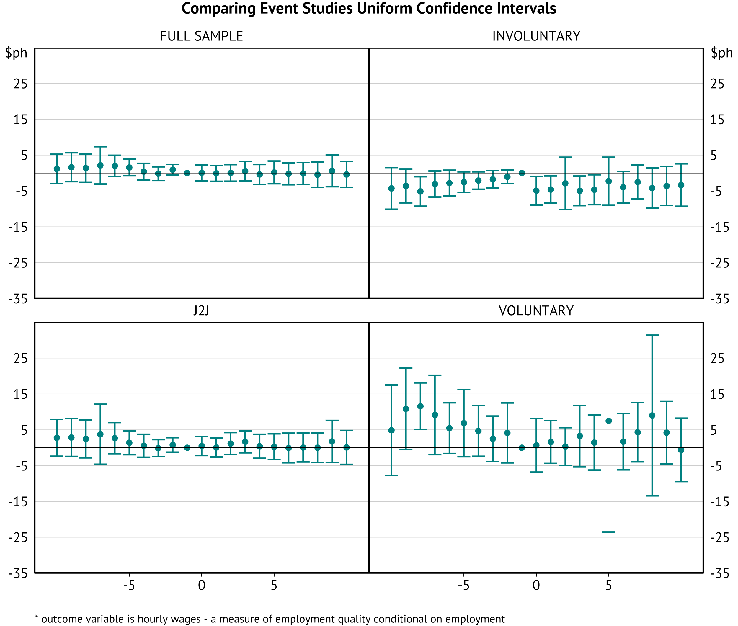

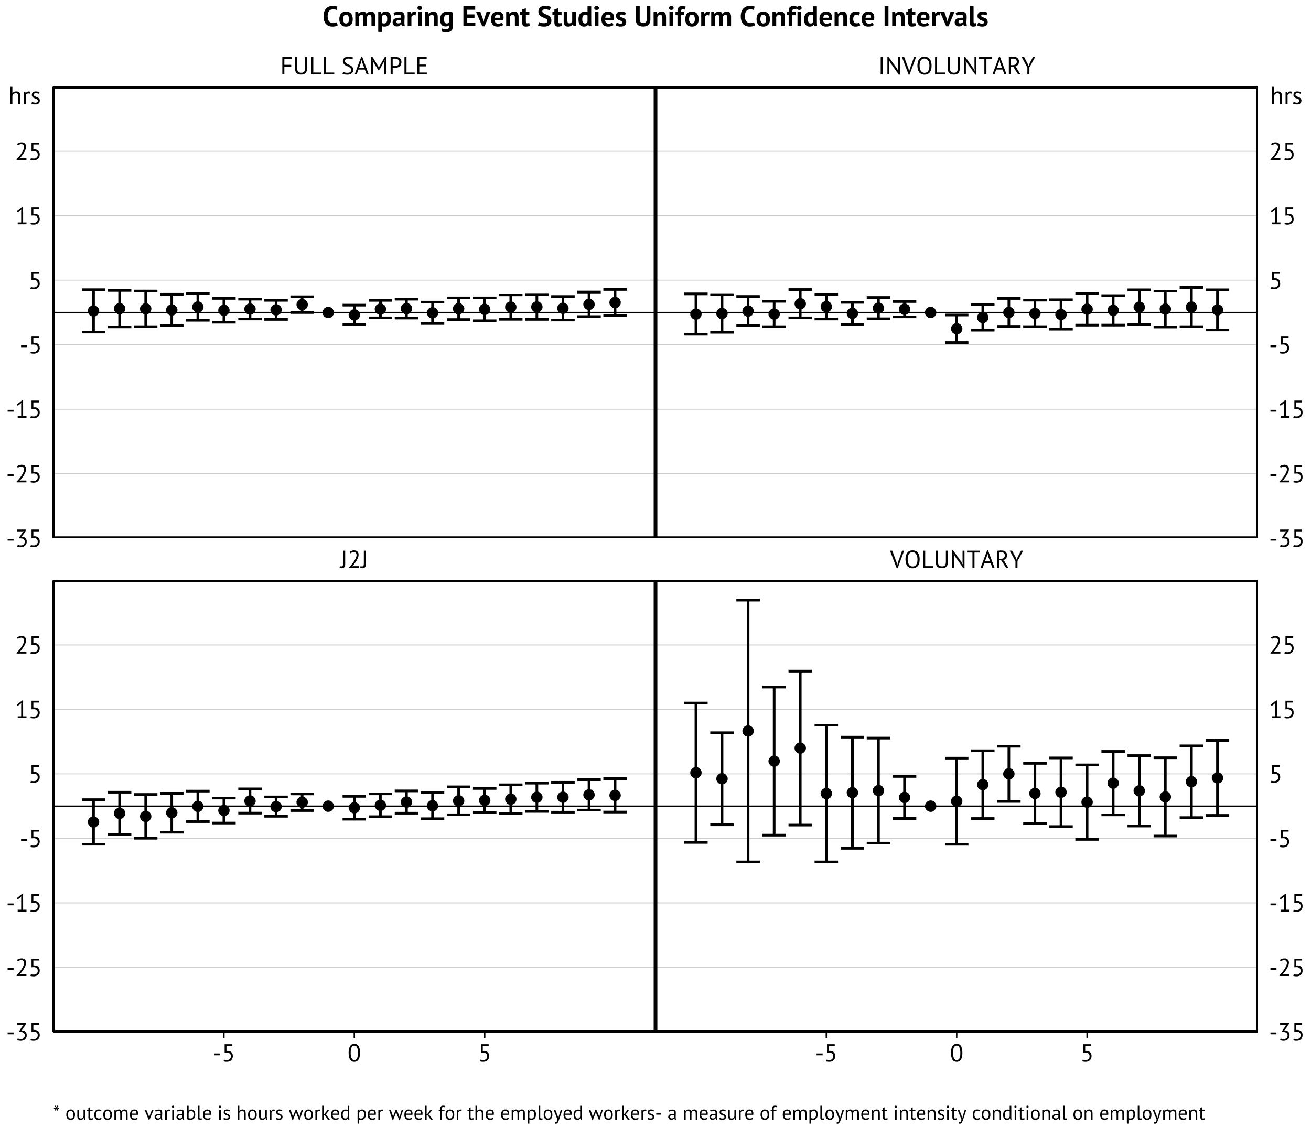

**The big criticism**

One issue with the analysis we’ve done this far is that it assumes that we observe the first instance of treatment for each worker or that each instance of unemployment (or job switching) is unrelated to subsequent changes. However, this appears unlikely. Doiron and Gørgens (2008) find that the length of unemployment spells tends to be related to future employment and unemployment spell incidence and length. This should make us interested in the first instance of job as it is likely going to be most informative about the decisions individuals make about exits from employment.

To this end, we can attempt this in HILDA by restricting our sample to:

1. Individuals who we observe reaching their final year of education
2. Are born after 1985 (as they are sufficiently young for us to observe early labour market history) even if we don’t observe them in education. Looking only at movements in full time employment (I.E the firs transition after full time employment)
3. The first option reduces the sample size dramatically. And our results don’t really provide much information. Especially since we impose a balanced panel.

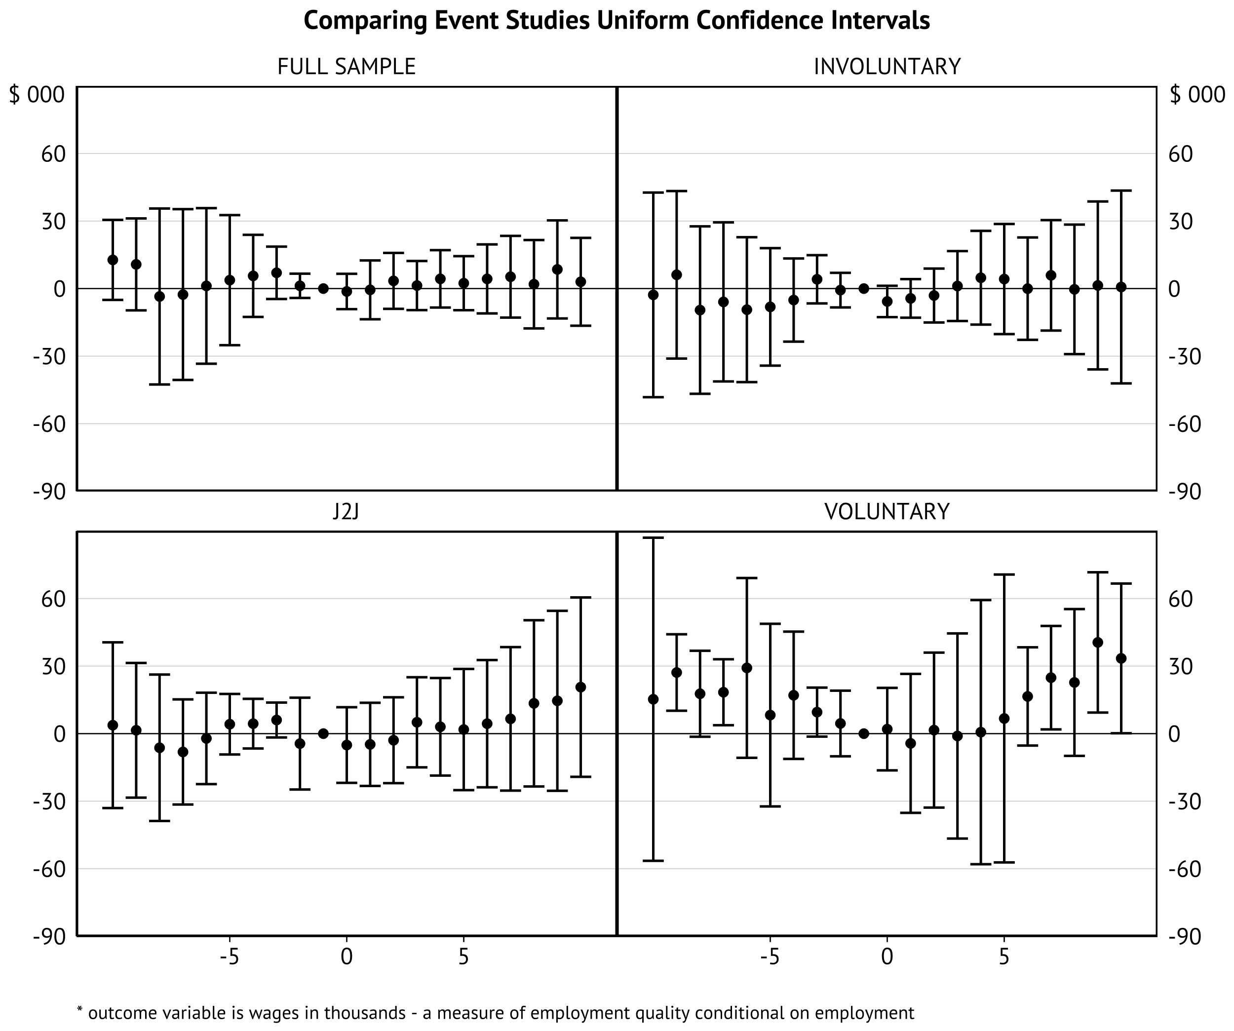

1. Below we have some of the event studies for the group of people who are born after 1985 and worked at least 21 hours a week on average in the year before separation. The aim with this specification is to pick up largely early career workers.

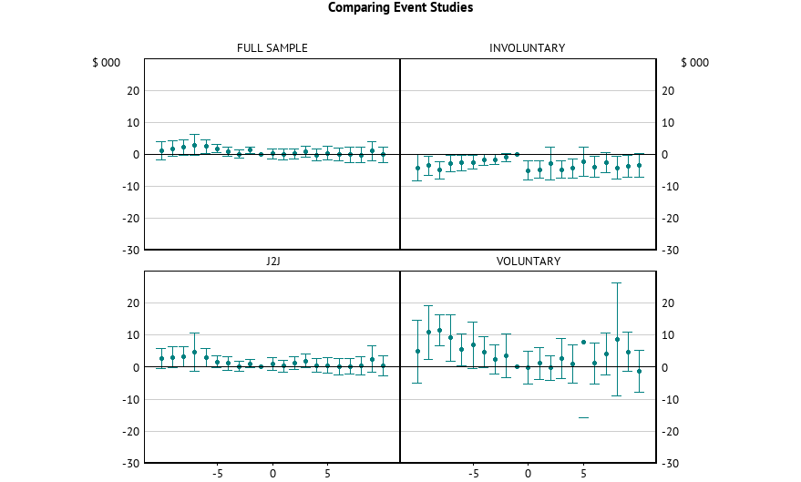

These results also aren’t super promising. They seem to show some odd pre-trends for the involuntary separators. These are worth looking into in a bit more detail but I think we should also have a crack with some alternatives (see below)

**Additional Potential solutions**

Other potential youth labour market issues could be done through using the LSAY data. Pending looking through the data for feasibility (I have access already). This would allow us to follow a few cohorts through to their early 30s with labour market and education histories and outcomes.

Potential issues – Infrequent, high attrition potentially correlated with income.